Web Development 2

CA1

2014

Darren Cosgrave-B00067349

Group 1

[B00067349@student.itb.ie](mailto:B00067349@student.itb.ie)



Assignment 1 - Form

I hereby certify that this material, which I now submit for assessment is entirely my own work. It has not been taken from the work of others save and to the extent that such work has been citied and acknowledged within the text of my work.

Signed: ………………………………

Date:

Student Number : B00067349

**CONTENTS**

**CosgraveDarren_B00067349_CA1**

html(javascript in the head of Gym_membership.html)

home_page.html

gym_membership.html

confirmation.html

**css**

confirmation.css

gym_membership.css

lay.css

nav.css

table.css

**images**

image_1

image_2

image_3

image_4

image_5

image_6

image_7

image_8

master_card

paypal_logo

visa

The home page with nav, section and table

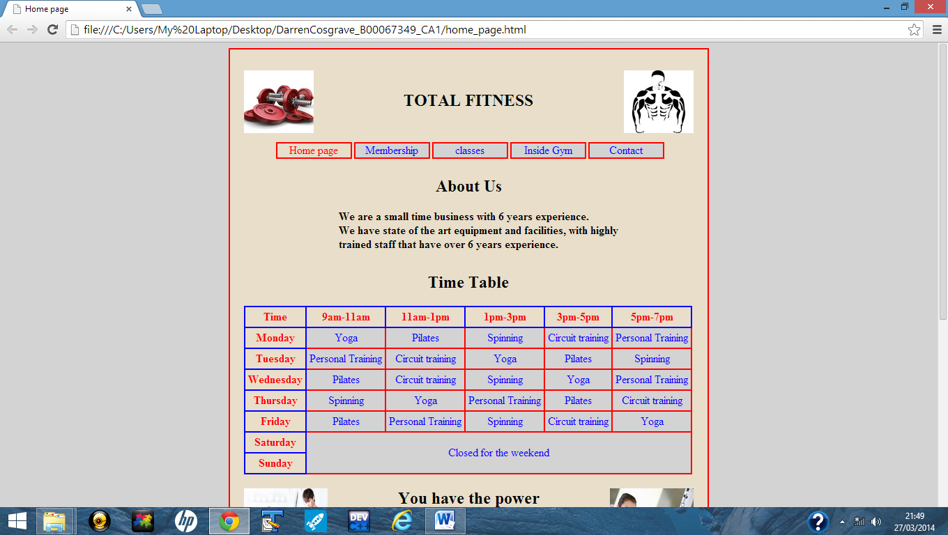

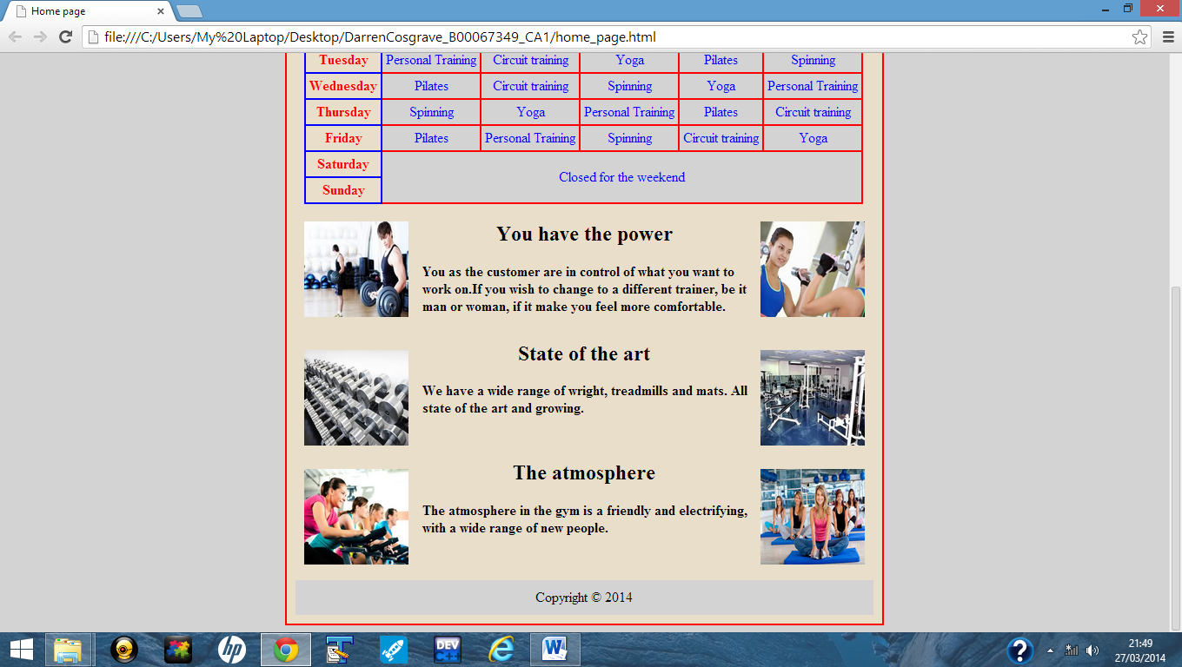

The form with a select, input’s, chechbox, radio and textarea

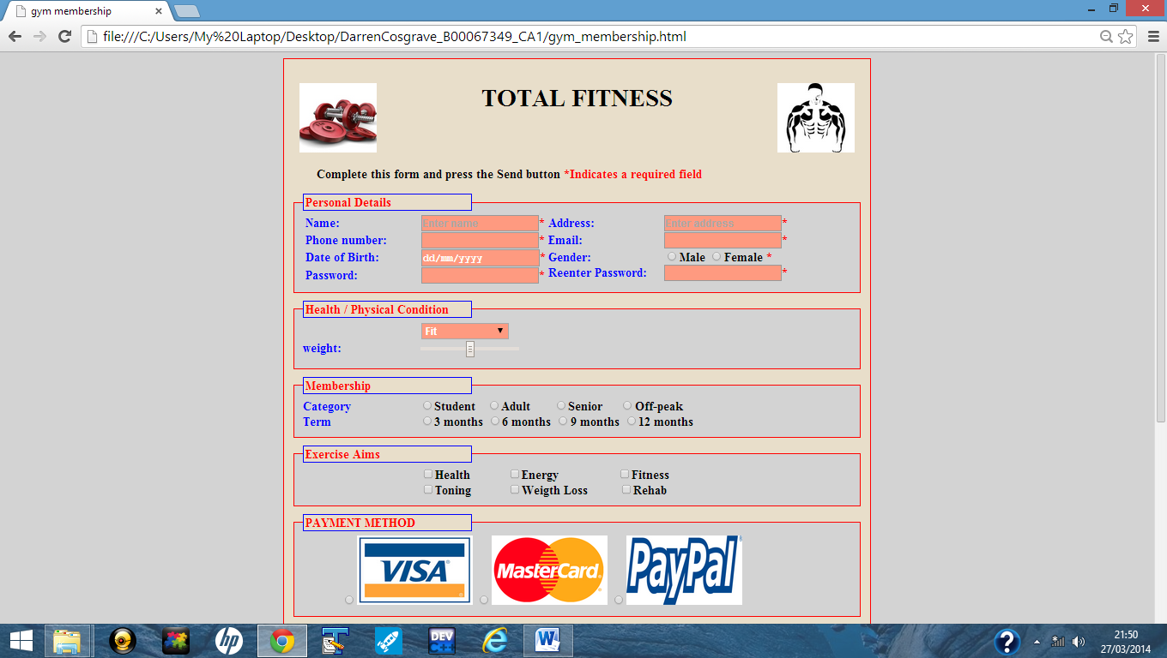

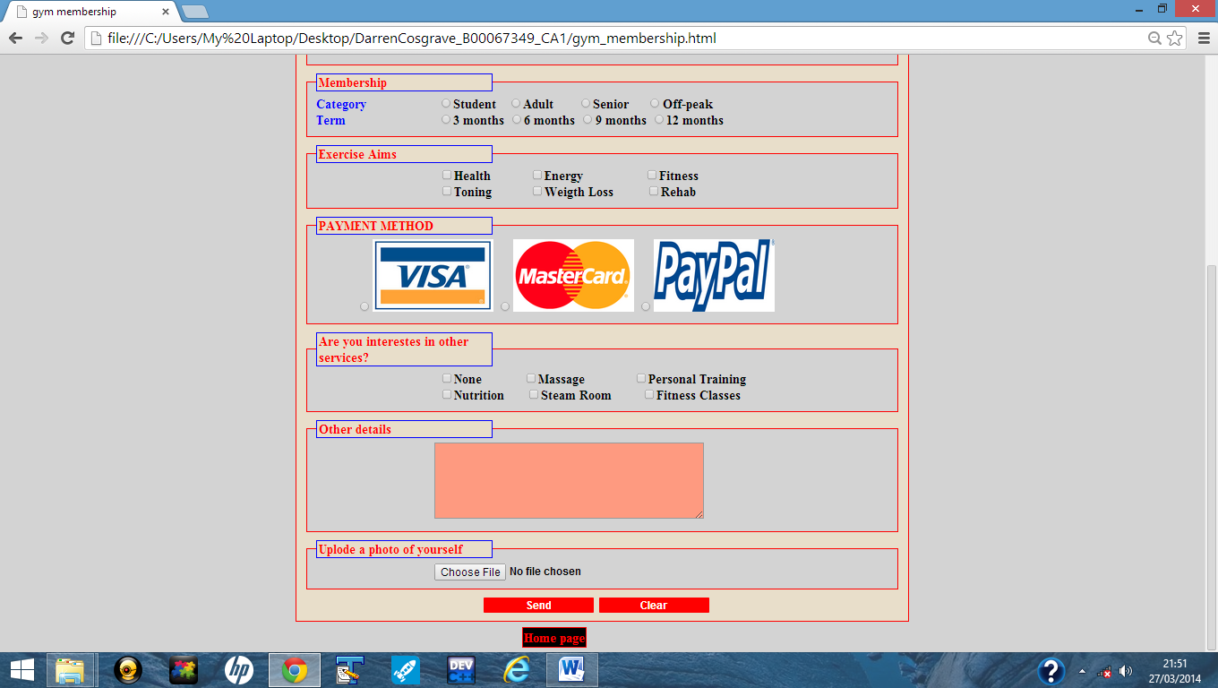

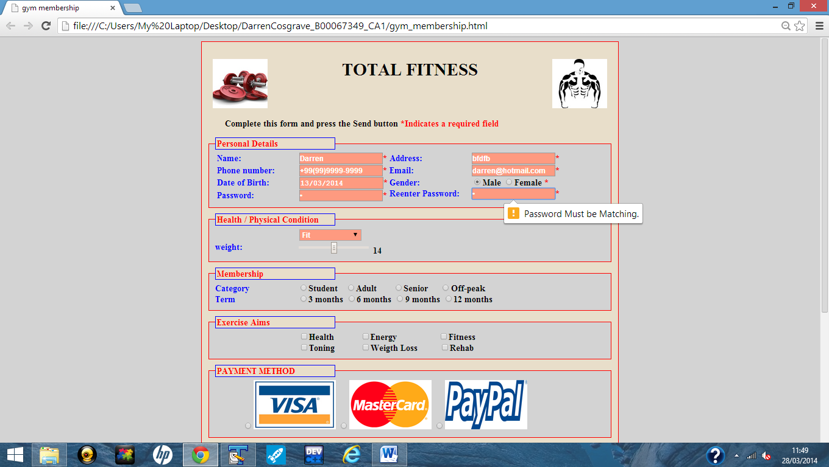

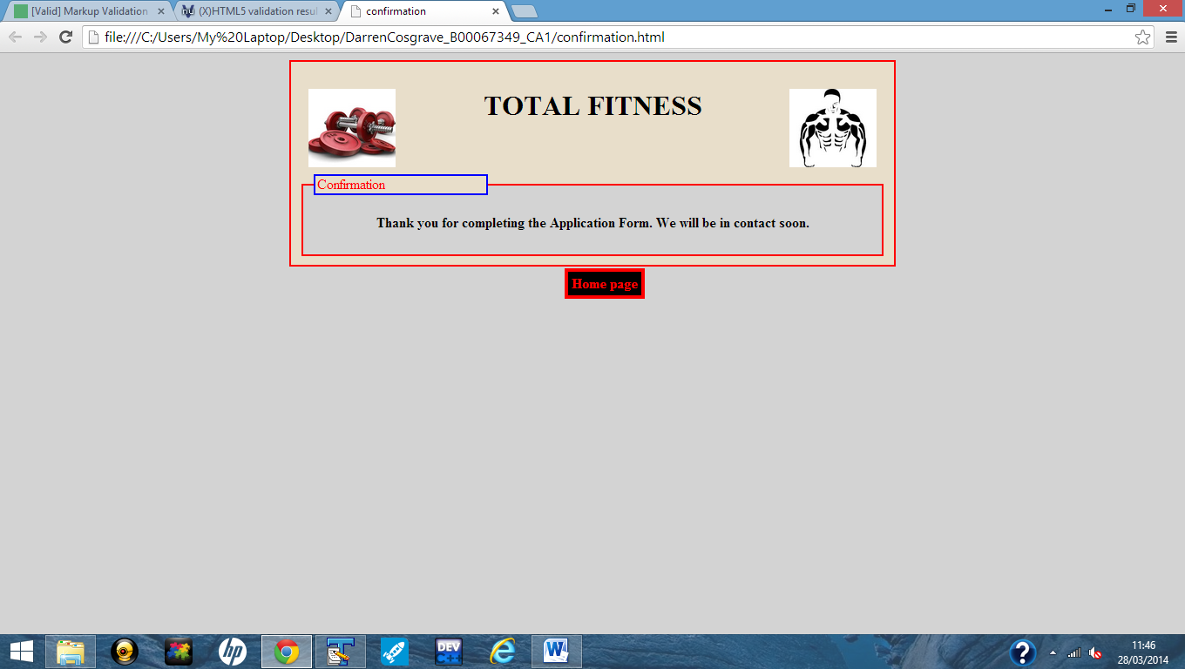

**Validated code**

